* <https://github.com/vadimlebovici/eulearning>: eulearning is a Python package to compute Euler characteristic profiles of multi-parameter filtrations.
* <https://arxiv.org/pdf/2212.01666v2/> : This paper contains Euler Charactersitic details for shape smoothening which is very useful for big data
* <https://github.com/lcrawlab/SINATRA>: Written in R for sub-image selection problem. A statistical model is used to classify the shapes based on their topological summaries. Here, we make use of a Gaussian process classification model with a probit link function. Thus, it can be used for summarisation of topology of 3-D shapes.
* <https://github.com/aidos-lab/dect-evaluation/tree/main/experiment>: Link for DECT evaluation by the author
* <https://github.com/aidos-lab/dect/tree/main>: Link for DECT evaluation by the author.

**My GitHub**

<https://github.com/Chandak-Keshav/Topo_PE>

**Possible Utility of DECT**

* Can be used for optimisation of point-clouds, mesh or grids.
* Can be used for benchmarking classification techniques against persistence diagrams methodology.
* Can be utilised as the loss function for classification tasks.

**Detailed Summary of "Differentiable Euler Characteristic Transforms for Shape Classification"**

**Objective**

* To enhance the traditional Euler Characteristic Transform (ECT), making it differentiable for integration into deep learning models.
* DECT bridges topological data analysis (TDA) and machine learning by addressing the limitations of ECT.

**Background**

* **ECT** is a topological descriptor that captures geometrical and topological features of data (e.g., graphs, point clouds, meshes).
* It uses the Euler Characteristic, a scalar value computed as the alternating sum of simplices (e.g., vertices, edges, faces).
* Traditional ECT suffers from:
  + Lack of task-specific learning.
  + Computational inefficiency in handling large datasets or complex data structures.

**Maths**

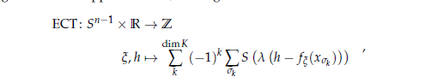

* σk​ is a k-simplex, and xσk​​ represents its feature vector.
* S is the sigmoid function, providing a smooth approximation.
* λ controls the steepness of the sigmoid, balancing approximation tightness.

**Contributions**

1. **Differentiable ECT (DECT):**
   * Introduced a smooth approximation of ECT using sigmoid functions, enabling gradient-based optimization.
   * Allows ECT to serve as a trainable layer or loss function in neural networks.
2. **Scalability:**
   * Implements parallelized computations with GPU acceleration, ensuring high performance across datasets and tasks.
   * Handles mixed data modalities (point clouds, graphs, meshes) efficiently.
3. **Improved Integration:**
   * Traditional ECT concatenates features, losing directional information. DECT uses a learnable embedding for Euler Characteristic Curves (ECCs), preserving key details.
   * Outputs are permutation-invariant and suitable for classification tasks.
4. **Applications:**
   * Applied to diverse datasets (synthetic and real-world), showcasing DECT’s flexibility in tasks such as shape classification and point cloud optimization.

**Key Methods**

1. **Mathematical Improvements:**
   * The ECT is redefined using differentiable summations of simplicial components with sigmoid functions.
   * Filters are applied to create multi-scale, nested subcomplexes, capturing topology across scales.
2. **Architecture:**
   * DECT is integrated into simple Multi-Layer Perceptrons (MLPs) and Convolutional Neural Networks (CNNs).
   * Combines ECCs into a high-dimensional representation using pooling layers and classifies with MLPs.
3. **Optimization:**
   * DECT optimizes both directions and point cloud positions to match target topological structures.
   * Supports both shape classification and geometry-aware point cloud adjustments.

**Experiments**

1. **Synthetic Data Classification:**
   * Tested on 2-manifolds (spheres, tori, Möbius strips) represented as point clouds, graphs, and meshes.
   * DECT achieved 100% classification accuracy across all modalities.
2. **Real-World Data:**
   * Applied on MNIST-Superpixel, a geometric graph dataset.
   * Results:
     + DECT (with CNNs) achieved competitive accuracy (97.2%) while being **10×** faster than GNN-based methods.
3. **Point Cloud Optimization:**
   * DECT adjusted noisy point clouds to fit target geometries (e.g., circles).
   * Demonstrated robustness to noise and flexibility in learning topological representations.
4. **Comparison with GNNs:**
   * Benchmarked against state-of-the-art methods on small graph datasets (e.g., BZR, COX2, Letter datasets).
   * Achieved similar or better performance with fewer parameters and faster runtime.

**Results**

* DECT provides:
  + **High accuracy:** Competitive with more complex models like Graph Attention Networks (GATs).
  + **Efficiency:** Orders of magnitude faster training due to vectorized operations and GPU support.
  + **Flexibility:** Works with varied data formats and sizes without requiring extensive preprocessing.

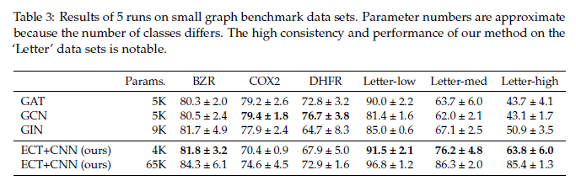

**Advantages**

* **Task-Specific Learning:** Unlike traditional ECT, DECT adapts its parameters to optimize for specific tasks.
* **Scalability:** Parallelized computations make DECT applicable to large-scale datasets.
* **Robustness:** Handles noisy and complex data effectively, preserving essential topological features.

**Euler Characteristic Transform Based Topological Loss for Reconstructing 3D Images from Single 2D Slices**

**Summary**

The proposed topological loss function, grounded in the Euler Characteristic Transform (ECT), significantly advances the field of 3D image reconstruction from single 2D slices. Its primary utility lies in enhancing the performance of neural networks, especially when working with limited data, which is a common challenge in biomedical imaging. By incorporating global topological features—such as connectivity and voids—this loss function provides a more nuanced understanding of the shapes being reconstructed, leading to better structural fidelity compared to traditional geometric loss functions.

One practical application of this approach could be in the medical field, where accurate 3D reconstructions of anatomical structures from 2D scans can aid in diagnostics and surgical planning. For instance, reconstructing the 3D shape of blood vessels or tumors from 2D imaging slices can provide crucial insights for healthcare professionals.

However, it's important to note that the implementation of this method comes with challenges. The codebase is quite large and cumbersome, making it difficult to navigate and utilize effectively. Additionally, there isn't a single point of execution for running the code, which can complicate the workflow for researchers and practitioners looking to apply this innovative technique in their work.

Q) Why not DICE loss function?

The DICE loss function, while commonly used in image segmentation tasks, primarily focuses on pixel-wise accuracy and does not account for the global structural properties of the shapes being reconstructed. This can lead to limitations in scenarios where the topological characteristics of the shapes are crucial for accurate reconstruction, such as in 3D image reconstruction from 2D slices.

In contrast, the proposed topological loss function based on the Euler Characteristic Transform (ECT) addresses these limitations by incorporating global topological features, such as connectivity, tunnels, and voids. This allows the model to better capture the underlying structure of the shapes, leading to more accurate and meaningful reconstructions. The ECT-based loss serves as an inductive bias that enhances the optimization process, particularly in cases where data is limited and traditional geometric losses like DICE may not suffice.

Thus, while DICE loss is effective for certain applications, it may not be the best choice for tasks that require a deeper understanding of the topological aspects of the data, making the ECT-based loss a more suitable alternative in the context of 3D image reconstruction.

Q) How simplicial and cubical complexes are being used here?

Ans: In the context of the proposed method for 3D image reconstruction, both cubical and simplicial complexes are utilized to represent the underlying structure of binary images. Here's how they are applied:

1. **Cubical Complexes**: These are particularly useful for representing grid-like structures, such as images. In a cubical complex, the 0-cubes correspond to individual voxels (the smallest units of 3D space), and higher-dimensional cubes (1-cubes, 2-cubes, etc.) are formed by connecting adjacent voxels that have a value of 1 (indicating they are part of the shape). This representation aligns well with the grid-like nature of images, making it easier to process and analyze the data in a structured manner.
2. **Simplicial Complexes**: While the paper primarily emphasizes cubical complexes due to their suitability for image processing, simplicial complexes can also be used to represent the same data. A simplicial complex consists of vertices, edges, and higher-dimensional simplices, which can capture the same topological features as cubical complexes but may be more abstract. The authors discuss the construction of these complexes to facilitate the computation of the Euler Characteristic Transform (ECT), which is central to defining the topological loss function.

By converting binary images into these complex structures, the authors can compute the Euler Characteristic and its variations, which serve as topological descriptors. These descriptors help in capturing important features of the shapes, allowing the proposed topological loss function to effectively guide the neural network during the reconstruction process. This approach enhances the model's ability to understand and reconstruct the 3D shapes from limited 2D data, leveraging the rich topological information encoded in the complexes .

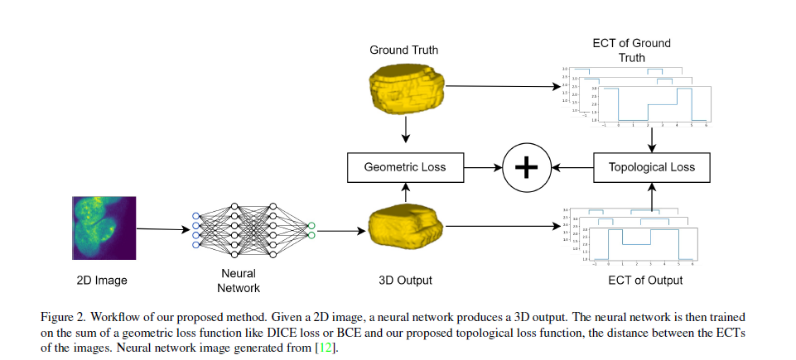

Q) How SHAPR is being utilised here?

Ans: In the proposed method for 3D image reconstruction, the SHAPR model serves as the foundational neural network architecture onto which the new topological loss function based on the Euler Characteristic Transform (ECT) is integrated. Here's how SHAPR is utilized in this context:

1. **Base Model**: SHAPR is initially designed for the task of 2D to 3D reconstruction, particularly in biomedical imaging. It provides a robust framework for processing 2D images and generating corresponding 3D shapes. The authors build upon this existing model to enhance its performance by introducing additional loss functions.
2. **Integration of Topological Loss**: The key innovation in this work is the incorporation of the ECT-based topological loss function into the training process of the SHAPR model. This loss function complements the traditional geometric loss functions (like DICE loss) that SHAPR typically uses. By adding the ECT-based loss, the model can leverage global topological features—such as connectivity and voids—during optimization, which helps improve the accuracy and quality of the reconstructed 3D shapes.
3. **Empirical Validation**: The authors demonstrate the effectiveness of the proposed ECT-based loss by training the SHAPR model on two benchmark biomedical datasets. They report significant improvements in various reconstruction metrics compared to the original SHAPR model and other prior approaches. This empirical validation showcases how the integration of the topological loss enhances the model's ability to reconstruct complex 3D structures from limited 2D data.

In summary, SHAPR acts as the core architecture for the reconstruction task, while the novel ECT-based loss function enhances its capabilities by incorporating topological insights, ultimately leading to better performance in 3D image reconstruction.

CHANGES REQUIRED:

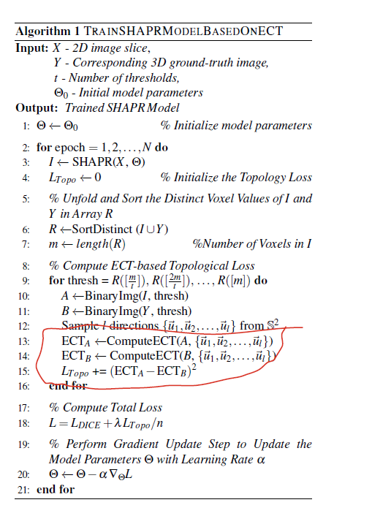

DECT Results:

**Moon Dataset(1000 points with varying noises):**

Evaluating for noise level: 0.1

Noise: 0.1, Test Accuracy: 100.00%

Evaluating for noise level: 0.2

Noise: 0.2, Test Accuracy: 97.50%

Evaluating for noise level: 0.3

Noise: 0.3, Test Accuracy: 86.00%

Evaluating for noise level: 0.4

Noise: 0.4, Test Accuracy: 83.00%

Evaluating for noise level: 0.5

Noise: 0.5, Test Accuracy: 79.50%

Evaluating for noise level: 0.6

Noise: 0.6, Test Accuracy: 73.00%

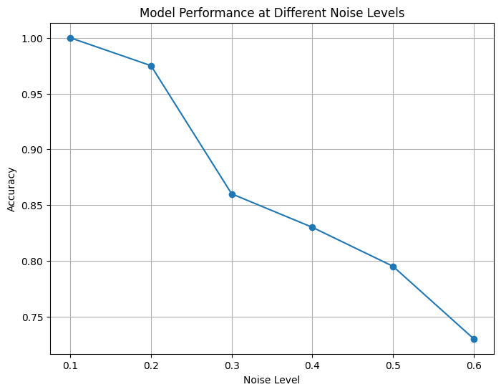

**Moon Dataset(5000 points with varying noises):**

Evaluating for noise level: 0.1

Noise: 0.1, Test Accuracy: 99.80%

Evaluating for noise level: 0.2

Noise: 0.2, Test Accuracy: 96.90%

Evaluating for noise level: 0.3

Noise: 0.3, Test Accuracy: 90.70%

Evaluating for noise level: 0.4

Noise: 0.4, Test Accuracy: 82.60%

Evaluating for noise level: 0.5

Noise: 0.5, Test Accuracy: 81.80%

Evaluating for noise level: 0.6

Noise: 0.6, Test Accuracy: 78.70%

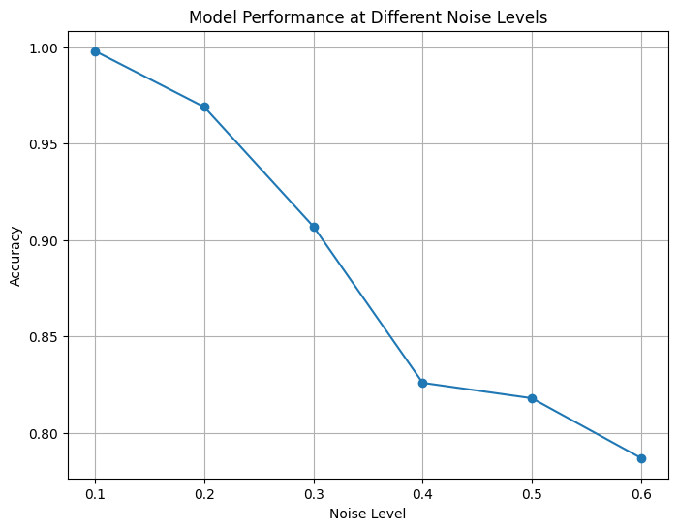

**Moon Dataset(10000 points with varying noises):**

Evaluating for noise level: 0.1

Noise: 0.1, Test Accuracy: 99.90%

Evaluating for noise level: 0.2

Noise: 0.2, Test Accuracy: 97.50%

Evaluating for noise level: 0.3

Noise: 0.3, Test Accuracy: 91.60%

Evaluating for noise level: 0.4

Noise: 0.4, Test Accuracy: 84.75%

Evaluating for noise level: 0.5

Noise: 0.5, Test Accuracy: 82.95%

Evaluating for noise level: 0.6

Noise: 0.6, Test Accuracy: 76.15%

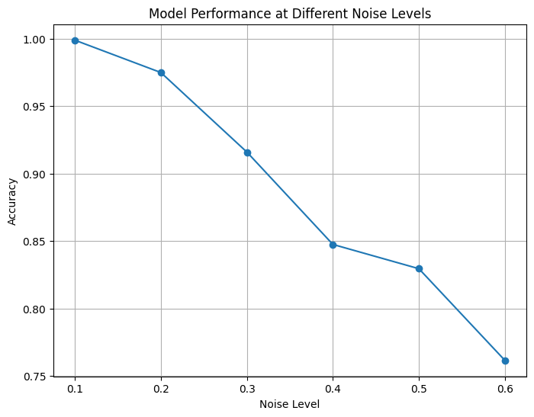

**Our Results:**

Moons Dataset(NN +DECT layer):

|  |  |  |  |  |  |  |
| --- | --- | --- | --- | --- | --- | --- |
|  | 0.1 | 0.2 | 0.3 | 0.4 | 0.5 | 0.6 |
| 1000 | 100% | 97.5% | 86.00% | 83.00% | 79.5% | 73.00% |
| 5000 | 99.80% | 96.90% | 90.70% | 82.60% | 81.80% | 78.70% |
| 10000 | 99.90% | 97.50% | 91.60% | 84.75% | 82.95% | 76.15% |
| 20000 | 99.85% | 96.97% | 90.70% | 84.82% | 76.45% | 79.38% |

Circles Dataset(NN+DECT Layer):

|  |  |  |  |  |  |  |
| --- | --- | --- | --- | --- | --- | --- |
|  | 0.1 | 0.2 | 0.3 | 0.4 | 0.5 | 0.6 |
| 1000 | 98.50% | 81.50% | 64.00% | 56.00% | 52.50% | 50.00% |
| 5000 | 96.70% | 84.10% | 74.90% | 69.10% | 62.00% | 54.50% |
| 10000 | 97.40% | 84.85% | 77.45% | 62.65% | 50.65% | 49.35% |
| 20000 | 99.22% | 87.40% | 77.85% | 69.53% | 50.38% | 48.88% |

**Topological Regulariser Result:**

Moons Dataset (SVM + rbf kernel):

|  |  |  |  |  |  |  |
| --- | --- | --- | --- | --- | --- | --- |
|  | 0.1 | 0.2 | 0.3 | 0.4 | 0.5 | 0.6 |
| 1000 | 100% | 97.33% | 91.67% | 84.67% | 82.01% | 75.00% |
| 5000 | 99.73% | 97.13% | 91.40% | 87.00% | 82.93% | 80.40% |
| 10000 | 99.83% | 97.00% | 91.90% | 86.50% | 81.90% | 78.50% |
| 20000 | 99.97% | 97.20% | 91.80% | 86.25% | 82.55% | 79.38% |

Circles Dataset(SVM + rbf kernel):

|  |  |  |  |  |  |  |
| --- | --- | --- | --- | --- | --- | --- |
|  | 0.1 | 0.2 | 0.3 | 0.4 | 0.5 | 0.6 |
| 1000 | 98.50% | 81.50% | 64.00% | 56.00% | 52.50% | 50.00% |
| 5000 | 96.70% | 84.10% | 74.90% | 69.10% | 62.00% | 54.50% |
| 10000 | 85.40% | 84.85% | 77.45% | 62.65% | 50.65% | 49.35% |
| 20000 | 83.15% | 69.03% | 62.53% | 59.53% | 57.27% | 56.00% |

Iris Dataset: 83.33% Test Accuracy With NN+DECT

93.33% Test Accuracy with TopoReg

Wine Dataset: 97.22% test accuracy With NN+DECT

**Summary of the Paper: The Weighted Euler Curve Transform for Shape and Image Analysis**

**Authors:** Qitong Jiang, Sebastian Kurtek, Tom Needham  
**Conference:** CVPR Workshop 2020

**Objective**

The paper introduces the Weighted Euler Curve Transform (WECT), an extension of the Euler Curve Transform (ECT), to provide a complete and computationally efficient descriptor for weighted simplicial complexes. This is particularly useful for analyzing medical imaging data, such as Glioblastoma Multiforme (GBM) tumors, by incorporating both shape and texture information.

**Key Contributions**

* **Generalization of ECT:**
  + The WECT extends ECT to weighted simplicial complexes, allowing it to capture both geometric and non-geometric features.
  + Proven to be a complete descriptor, meaning it uniquely characterizes a shape and its weighting function.
* **Mathematical Framework:**
* **Algorithm:**

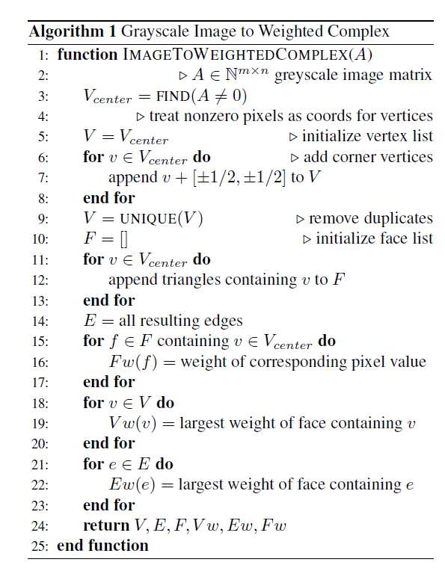

* **Injectivity properties:**

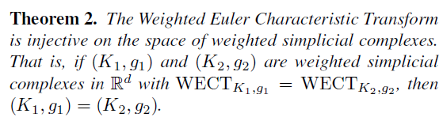

* **Applications in Image Analysis:**
  + Converts grayscale medical images into weighted simplicial complexes.
  + Did the analysis for 63 tumor images.
  + Uses WECT for shape and texture-based clustering of GBM tumors.
  + Demonstrates correlation between tumor clusters and patient survival times.

**Utility of WECT**

1. **Medical Imaging**
   * Effective in analyzing tumor shapes and textures.
   * Helps distinguish tumor types and predict patient outcomes.
2. **Shape Classification**
   * Applied to MNIST digit classification, outperforming ECT and raw image-based methods.
   * Demonstrates robustness in recognizing topological features.
3. **Computational Efficiency**
   * WECT is easier to integrate into statistical models than persistent homology.
   * Can be efficiently computed using standard L2 norm-based distance metrics.
4. **Pattern Recognition and Machine Learning**
   * Provides a structured way to incorporate topological data analysis (TDA) into ML models.
   * Can be used in graph-based learning, biometrics, and material science.

**Comparison with Other Methods**

| **Method** | **Captures Shape** | **Captures Texture** | **Computational Cost** |
| --- | --- | --- | --- |
| Persistent Homology | Yes | Limited | High |
| Euler Curve Transform (ECT) | Yes | No | Low |
| WECT (Proposed) | Yes | Yes | Moderate |

**Experimental Results**

**MNIST Digit Classification**

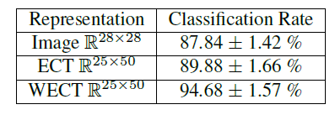

**GBM Tumor Clustering and Survival Analysis**

| **Cluster** | **Mean Survival (Months)** | **Median Survival (Months)** |
| --- | --- | --- |
| Cluster 1 (Low) | 6.7 | 6.2 |
| Cluster 2 (Medium) | 12.9 | 9.6 |
| Cluster 3 (High) | **20.2** | **15.2** |

**Advantages over Persistent Homology:**

**1)** Trivial to register transform like translations and rotations.

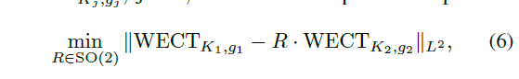

R here is the rotation group of the image used for calculations.

**Future Work**

* Improving WECT for use in more advanced machine learning models.
* Developing better inversion algorithms for practical reconstruction from WECT data.
* Exploring applications beyond medical imaging, such as molecular modeling and material sciences.

**Conclusion**

The WECT provides a powerful and computationally feasible method for analyzing weighted shape data. By integrating both shape and texture, it enhances medical image analysis, pattern recognition, and classification tasks. The framework offers significant improvements over traditional topological descriptors and holds great potential for future research in various fields.

**Variants of the ECT:**

* Thresholding pixel values in the image and building restricted two-dimensional complexes.
* Using the pixel values to build a three-dimensional simplicial complex.

Unsatisfactory performance on the tumor dataset, although they may be viable approaches for other applications.

**Short synopsis of 2020 SECT paper:**

Based on the above analysis, SECT is just ECT+GPR(Gaussian Process Regression). WECT performs better but will be worse in case of noisy data.

**SECT as a Feature Extractor**

* SECT converts complex 3D tumor shapes into a structured set of smooth curves, which encode topological information such as holes, cavities, and connectivity.
* These curves live in a Hilbert space, making them mathematically well-suited for statistical learning.

**GPR as a Prediction Model**

* GPR takes SECT curves as input features and maps them to clinical outcomes, such as patient survival rates or tumor progression.
* Unlike traditional regression, GPR does not assume a fixed function but instead learns a distribution over possible functions, making it flexible and uncertainty-aware.

**WECT Circles + Moons Result:**

### Results for Moons Dataset ###

| N_Samples | Noise | Accuracy |

|-----------|-------|----------|

| 1000 | 0.1 | 1.0000 |

| 1000 | 0.2 | 0.9750 |

| 1000 | 0.3 | 0.9200 |

| 1000 | 0.4 | 0.8600 |

| 1000 | 0.5 | 0.8200 |

| 1000 | 0.6 | 0.7700 |

| 5000 | 0.1 | 0.9980 |

| 5000 | 0.2 | 0.9700 |

| 5000 | 0.3 | 0.9080 |

| 5000 | 0.4 | 0.8660 |

| 5000 | 0.5 | 0.8240 |

| 5000 | 0.6 | 0.8070 |

| 10000 | 0.1 | 0.9990 |

| 10000 | 0.2 | 0.9755 |

| 10000 | 0.3 | 0.9245 |

| 10000 | 0.4 | 0.8730 |

| 10000 | 0.5 | 0.8300 |

| 10000 | 0.6 | 0.7975 |

### Results for Circles Dataset ###

| N_Samples | Noise | Accuracy |

|-----------|-------|----------|

| 1000 | 0.1 | 0.9650 |

| 1000 | 0.2 | 0.7750 |

| 1000 | 0.3 | 0.6700 |

| 1000 | 0.4 | 0.6250 |

| 1000 | 0.5 | 0.5350 |

| 1000 | 0.6 | 0.5300 |

| 5000 | 0.1 | 0.9950 |

| 5000 | 0.2 | 0.8730 |

| 5000 | 0.3 | 0.7680 |

| 5000 | 0.4 | 0.7080 |

| 5000 | 0.5 | 0.6320 |

| 5000 | 0.6 | 0.6020 |

| 10000 | 0.1 | 0.9920 |

| 10000 | 0.2 | 0.8775 |

| 10000 | 0.3 | 0.7715 |

| 10000 | 0.4 | 0.6990 |

| 10000 | 0.5 | 0.6460 |

| 10000 | 0.6 | 0.6290 |

### Results for Moons Dataset ###

| N_Samples | Noise | Accuracy |

|-----------|-------|----------|

| 20000 | 0.1 | 0.9988 |

| 20000 | 0.2 | 0.9730 |

| 20000 | 0.3 | 0.9173 |

| 20000 | 0.4 | 0.8650 |

| 20000 | 0.5 | 0.8233 |

| 20000 | 0.6 | 0.7950 |

### Results for Circles Dataset ###

| N_Samples | Noise | Accuracy |

|-----------|-------|----------|

| 20000 | 0.1 | 0.9958 |

| 20000 | 0.2 | 0.8862 |

| 20000 | 0.3 | 0.7752 |

| 20000 | 0.4 | 0.7083 |

| 20000 | 0.5 | 0.6590 |

| 20000 | 0.6 | 0.6268 |